Code Review: I1905035
Reviewer: James Wood
Date: Feb 2nd, 2023
Bugs
- Potential bug when running DataTransfer on a database with “bad data” in any of the Import Order tables.
- Instead of using WITH CHECK, use WITH NOCHECK. This will ignore all pre-existing data.
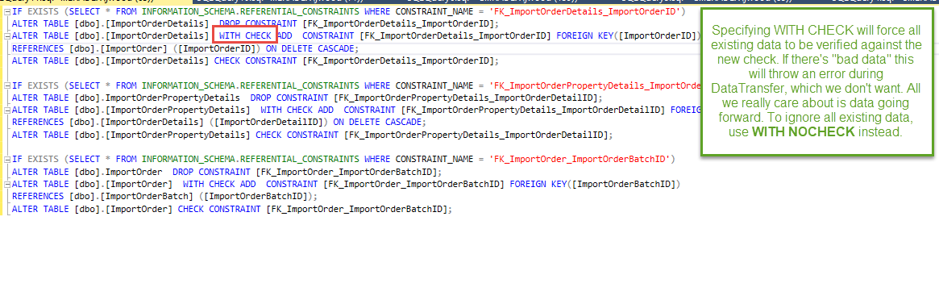
UI(Alignment, naming, standardization)
- Not applicable.
Error Handling(Behind events, appropriate parameter checking)
- Not applicable.
Message Boxes (Grammar, spelling, captions, appropriate icons)
- Not applicable.
Design/Architecture (Duplication, appropriate project, namespaces)
- Not applicable.
Performance (Minimize DB hits, excessive loops, queries, scalable)
- Nit: Very minor suggestion for IF EXISTS() statements.
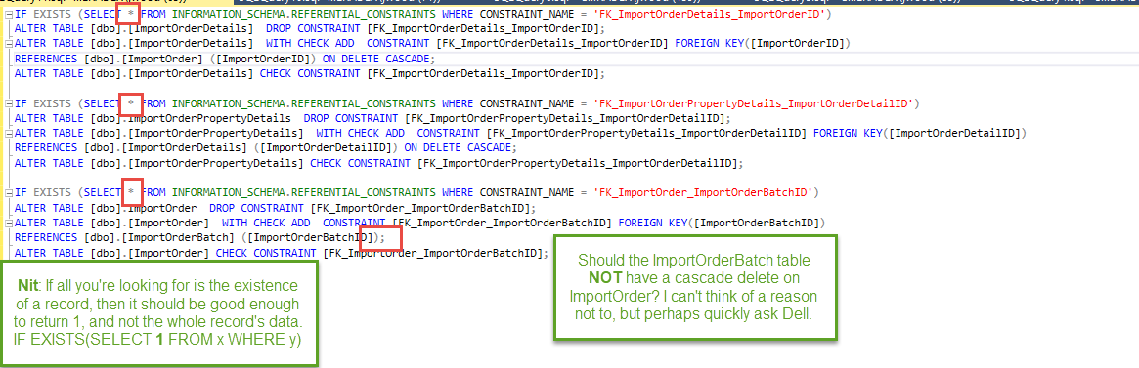
Comments (Useful, explains why rather than how)
- Not applicable.
Cleanup (Dispose code, remove handlers, large data objects)
- Not applicable.
Readability (Well-named variables, methods, clear algorithm, is it understandable)
- Looks good.
Internal Standards
- Our new standard for database constraints is to list the Table name first, then _XX_ where ‘XX’ is the check type, then the field name.
In this case, we’d have ImportOrderDetails_FK_ImportOrderID, for example.
- Please correct all references to foreign key names in the query.
- See this document, for reference: Y:\Documents\SOPs\Development\Seradex Sql Object Naming Convention.docx
Extras
- Nothing else to note.

